October 2021

Background Screening
Policy and Process Considerations
for Sport Organizations

Background Screening Policy and Process Considerations for Sport Organizations

Background screening is one of three pillars in the Responsible Coaching Movement.

Background screening ensures that applicants to your sport organization such as employees, coaches and volunteers meet the important requirements to participate in sport
activities. Screening includes comprehensive job postings, visible policies and processes, criminal record
checks, interviews, and reference checks. All are equally important. Organizations are encouraged to determine the level of risk of an applicant and define/document how they will undertake to screen candidates. A summary chart is located at the end of the document.

This document was prepared by the CAC to assist sport organizations in the development of screening policies and processes. Each organization must ultimately develop the policy and process they wish to follow to meet the needs of their community. The type of criminal record check a candidate needs, the validity of that check (in length of time), and the process they will use to address positive checks are at the discretion of the organization. Other considerations depend on the scope of the person’s involvement with the
organization, provincial/territorial laws and human rights considerations.

A template Screening Policy for Sport Organizations can be accessed here.

Understanding the different types of criminal record checks
If you are requesting a criminal record check, the person must consent to the check via an application form and/or screening disclosure form.

Validity: A valid check is only as good as the day it was completed however a general timeframe is that one that has been completed within 6 months or less is acceptable.
Frequency: A recommended maximum length of time between checks is three years and a disclosure form may be requested each year. It is at the discretion of the sport organization to determine the appropriate length of time between criminal record checks.
Age: Criminal Records contained within the RCMP National Repository typically exist for people 18 years of age or older. If you require a person under 18 years of age to complete a CRC, a local police information
check may be required.
Confidentiality: Ensure proper document management to protect the privacy of personal information.

Canadian Criminal record check (CRC): a search of adult convictions held within the RCMP National Repository of Criminal Records. CRCs can be completed online within 24 hours. Not recommended as this does not contain Local Police Information.

Local Police Information (LPI) Check: searches of additional conviction and selected non-conviction information which may be relevant within both national and local police data sources. LPIs may take up to three months to complete. You must present yourself at the police station.

Enhanced Police Information Check (E-PIC): is a search of local police information and the RCMP National Repository of Criminal Records to determine whether the individual has a criminal conviction for which a pardon has not been granted and whether select non-conviction information may be relevant to the screening process. E-PICs can be completed online within 24 hours. An E-PIC is recommended and can be shared by the applicant with multiple organizations.

Vulnerable Sector Verification (VSV): A VSV includes three checks: a search of the National Repository of Criminal Records in Canada, a Local Police Information check within Multiple Databanks and record suspensions formerly pardons) for sex-based offences, non-conviction information, and charges related to the predation of a child or other vulnerable person. VSVs may take up to three months to complete and you must present yourself at the police station. If an organization requires a VSV and it will take up to three months, consider asking the applicant to complete an E-PIC until the results of the VSV can be provided.

Note: Based on recent changes to legislation, any offence committed as an adult after March 12th, 2012 would not be eligible for a pardon, meaning anyone born after March 12, 1994 (18+ years prior) would not have a pardoned sex offence.
International Record Checks
International Record Checks are strongly recommended if the applicant is a Canadian citizen who has been out of the Country for 6 months or more. A person who is not born in Canada or who has not resided in
Canada for at least five (5) years, must obtain the equivalent of a VSV from any country where they have spent
183 days or more within the last five (5) years, prior to their arrival to Canada. If any of those documents are in a language other than English or French, the documents should be provided with a translation from a certified
translator.

An international record check consists of felony and misdemeanor criminal convictions, any pending criminal cases, and any history of incarceration. The cost depends on the country. International Records Checks can take up to 4-5 days to complete. They can be accessed
here https://www.sterlingbackcheck.ca/services/global-checks/ or through another provider.

Considerations for Sport Organizations for Positive Checks

If an applicant’s check comes back showing a charge or conviction, determining the next steps is at the discretion of the Screening Committee, per the Policy. The Committee should be sent the applicant’s documents with the applicant’s name redacted, if possible.

The Screening Committee should consist of individuals who have knowledge in screening, legal, human resources, human rights, and other relevant experience. The Committee should have a terms of reference and be aware of their responsibilities under the Policy.

When considering applications, the Committee should:

A. Consider the job function or role of the applicant (examples: coaching vulnerable persons, driving people, managing/handling money)
B. Weigh the applicant’s charge(s) or conviction(s) with the amount of time that has passed, the nature of the offense(s), and the penalty (if any) served by the applicant.
C. Determine whether to accept the application, reject the application, or request more information from the applicant, before making a determination.
D. Reject applications that show charges or convictions for offenses against a minor.
E. Communicate the decision, in written form, to the organization’s representative who will share it with the applicant. Decisions can be appealed per the organization’s policies for appeals.
F. Ensure adequate security safeguards to protect the confidentiality of personal information
against unauthorized access, disclosure, use or modification.

Additional Information and Resources

RCMP Types of Criminal Background Checks
Privacy Act of Canada Recommend viewing Provincial/Territorial Privacy Acts
Youth Criminal Justice Act
Screening Canada The Cost of a Bad Hire
Charity Village Guidance for Non-Profits – Includes a Webinar
Charity Village Criminal Record Checks Brochure
The Screening Handbook Volunteer Canada

Summary of Considerations for Background Screening

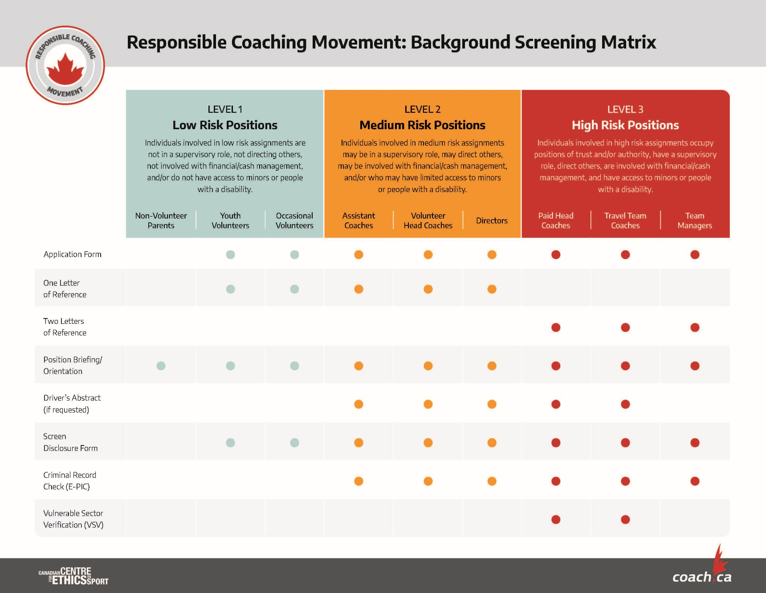

For additional information contact sportsafety@coach.ca

