
Learning Facilitator Guide


When adapting the manual…
<Insert sport logo >

NCCP <MODULE NAME>
Learning Facilitator Guide
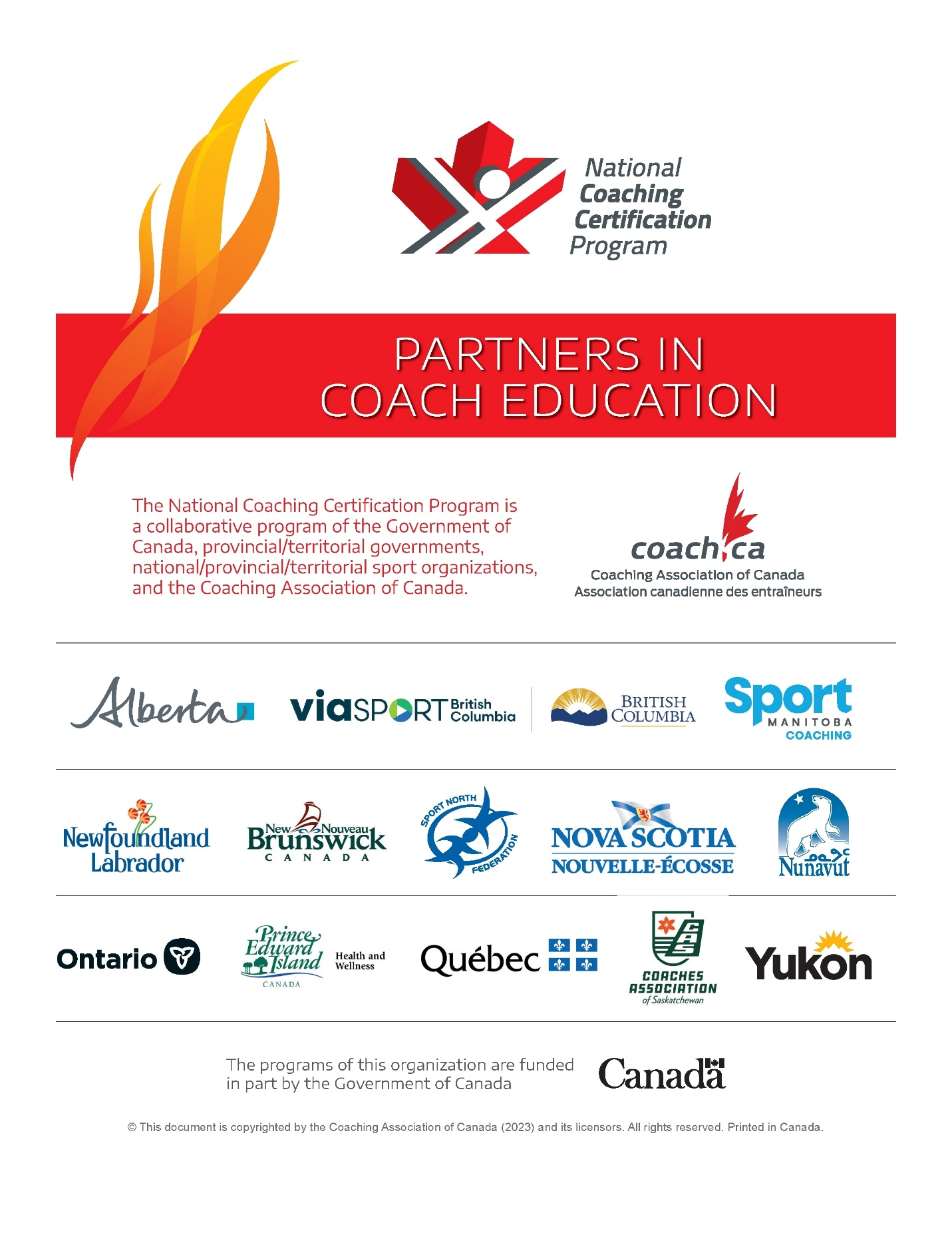

When sportifying this manual…
Ensure this Partners Page is the most up-to-date version. All current NCCP logos and manual components are located in the PhotoShelter:
https://coach.photoshelter.com/gallery/Partners-Page/G0000WejcZ1CXTy4/C00001CZGRb984w8
Use the passcode CAC!2010 to download images.

Table of Contents
Acknowledgements 3
Preface 3
Who is this document for? 3
What is the purpose of this document? 3
How does this training happen? 3
How is this document organized? 3
Workshop overview 4
National Coaching Certification Program 5
The NCCP 1–3–5–7 definition 5
NCCP Core Competencies 6
Learning Outcomes 7
1 Introduction 8
2 Section 2 12
3 Section 3 15
4 Conclusion 16
Appendices 18
Appendix A: Principles of adult education and learner-centered delivery 18
Appendix B: Learning Facilitator tips and tools 19
Appendix C: Virtual Delivery 22
Appendix D: Recognition of traditional lands of the First Nations, Inuit, and Métis peoples as the keepers of the land 25

Acknowledgements
<Insert instructional designers and contributors>

The Collection, Use and Disclosure of Personal Information
The Coaching Association of Canada collects your NCCP qualifications and personal information and shares that with all NCCP partners, according to the privacy policy detailed online at www.coach.ca. By participating in the NCCP, you are consenting to your information being gathered and shared as detailed in the privacy policy. If you have any questions or would like to abstain from participating in the NCCP, please contact coach@coach.ca.
This document is copyrighted by the Coaching Association of Canada and <NSO> (<YEAR>) and its licensors. All rights reserved. Printed in Canada.
No part of this publication may be reproduced, stored in a retrieval system, or transmitted, in any form or by any means, without the express written permission of the Coaching Association of Canada.
The National Coaching Certification Program (NCCP) is funded in part by the Government of Canada.

Preface

Who is this document for?
This Learning Facilitator Guide (LFG) is for Learning Facilitators responsible for delivering <NSO>’s <MODULE NAME> module in the National Coaching Certification Program (NCCP).

What is the purpose of this document?
The purpose of this guide is to provide Learning Facilitators (LFs) with a step-by-step resource on how to facilitate the training of the NCCP <MODULE NAME>.

How does this training happen?
Training for the NCCP <MODULE NAME> is a <XX-hour/day> module that covers XX topics:
- <List module topics here>

How is this document organized?
This document is organized by the workshop’s XX topics.
Each section contains a multi-page table that sets out the step-by-step way to deliver that section’s learning activities. Each learning activity provides the following information:
- Activity title and time — This provides a name and recommended total time for the activity.
- Cumulative time — This tool helps you track how far you are into the workshop. Make sure to note the workshop start time and refer to the clock to stay on schedule.
- Instructions and notes — These describe what you should do during the activity and provide additional information on the learning activity. For example, the how and why of the activity, key points on the discoveries that coaches may make during the activity, and descriptions of what to do and look for during the activity.
- Resources — If an activity requires materials, you’ll find them listed in the resource’s column.

Workshop overview
This overview is a high-level summary you can use when delivering the workshop.
Learning activities | Time
Section 1: Introduction | Section time: 10 minutes
1. Introduction, plenary presentation | 10 minutes
Section 2: | Section time: XX minutes
1. | XX minutes
2. | XX minutes
3. | XX minutes
Section 3: | Section time: XX minutes
1. | XX minutes
2. | XX minutes
Section 4: | Section time: XX minutes
1. | XX minutes
2. | XX minutes
Section 5: | Section time: XX minutes
1. | XX minutes
2. | XX minutes
3. | XX minutes
4. | XX minutes
Section 6: | Section time: XX minutes
1. | 30 minutes
2. | 15 minutes
Section 7: Conclusion | Section time: XX minutes
1. Debrief and action card, individual reflection | XX minutes
2. Closing | XX minutes
Total time NCCP <Module Name> | XX hours, XX minutes  (XXX minutes)

National Coaching Certification Program

The NCCP 1–3–5–7 definition
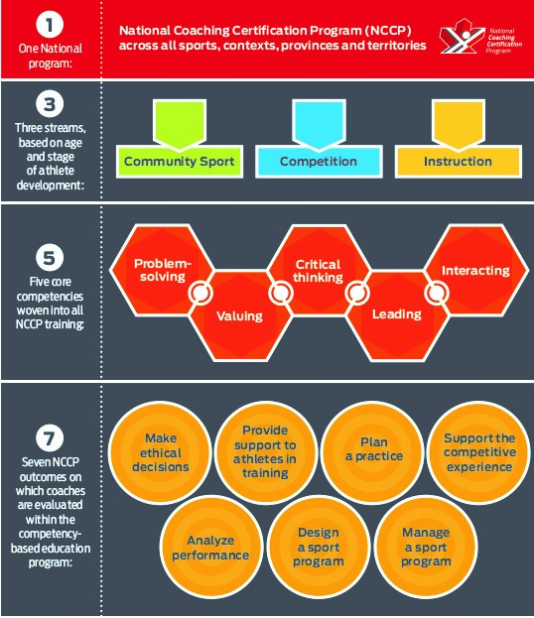

NCCP Core Competencies
As coaches progress through this module, they will work on developing 5 core competencies to help them become a more effective coach and have a more meaningful impact on athletes’ experience. The competencies are problem-solving, valuing, critical thinking, leading and interacting.

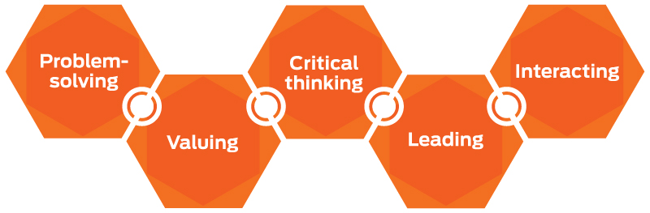
Here are some of the ways these competencies come into play in the NCCP <MODULE NAME> module:
<Under each competency, list/describe any relevant activities that the coaches will apply during this module>
Problem-solving

Valuing

Critical thinking

Leading

Interacting

Learning Outcomes
The learning activities in this module are designed to enable you to help less experienced coaches develop their coaching skills. In particular, the coaches will be able to do the following after finishing this module: <List the learning outcomes of this module>

1 Introduction
Workshop preparation
Instructions and notes | Resources
- Before the workshop, refer to Appendix A (Principles of adult education and learner-centered delivery), Appendix B (Learning Facilitator Tips and Tools). | - LF Guide, appendices A and B
- Arrive at least 30 minutes before the start time to prepare materials, A/V equipment and the facility. Required materials for the delivery of this workshop include: <list any applicable materials needed for learning activities>  - Flip charts and markers  - Masking or painter’s tape  - Coach workbooks  - Computer and projector  - Speaker | - LF Guide
My notes:

Pre-workshop activity
Instructions and notes | Resources
- Display slide #1 as participants arrive. | - Slide #1  <insert thumbnail of slide #1>
- Around the room, display the NCCP core competencies and workshop learning outcomes, written on flip chart paper. Use the flip charts to continue to reinforce these concepts throughout the workshop. | - Flip chart paper  - LF Guide
- Ensure coaches have a copy of the Coach Workbook (either hard copy or digital, whichever is applicable for your workshop)
- Collect NCCP numbers
- Confirm whether anyone needs special accommodations (such as mobility or sensory) during the workshop, and help to accommodate them.

My notes:

Welcome and introduction
Activity time: 10 minutes
Materials: Coach Workbook
Instructions and notes | Resources
- Introduce yourself to the group and welcome them to the NCCP <MODULE NAME> | - For each instruction/note, list the resources you will need. This could include references to slide numbers, coach workbook page numbers, flip chart, other tools, etc.
- Thank the traditional territory for the opportunity to train today. If possible, please customize the following thank you to acknowledge the specific First Peoples on whose traditional territory you’ll be delivering the workshop:

“In the NCCP, we respect and acknowledge the Indigenous (First Nations, Inuit, and Métis) peoples of Canada as the Keepers of the Territory upon which we’ll be learning today.”

- Address “housekeeping” items at the beginning of the workshop: the schedule, breaks, washroom location and an Emergency Action Plan (EAP).
- Introduce the National Coaching Certification Program (NCCP):

  - 1 national program (across all sports, contexts and provinces and territories)

  - 3 streams (based on age and stage of athlete development)

  - 5 core competencies (woven into all NCCP training)

  - 7 NCCP outcomes (on which coaches are evaluated within the competency-based education program)

- Introduce the core competencies:

  - Problem-solving, valuing, critical thinking, leading and interacting

- Tell participants they’ll use all these core competencies in the workshop.
- All coaches in Canada are expected to demonstrate these core competencies on a daily basis.

- Introduce the learning outcomes:
  - <list the learning outcomes here>

- It’s important as the Learning Facilitator to understand these learning outcomes, continually draw upon them, and make links back to them throughout the workshop. Having the outcomes listed on flip chart paper, displayed around the room, allows the participants and the learning facilitator to continue to draw upon the learning outcomes.

- Introduce the process you’ll follow:
  - Small-group tasks, pair tasks, individual tasks, debriefs, personal reflection and mini-lectures

My notes:

At the end of this section, you should be 10 minutes into the workshop.

2 Section 2
Section time: XX minutes
Learning outcome: <list the learning outcome applicable to this section>

<Name of Activity> example plenary, group discussion, Pairs activity, etc.
Activity time: XX minutes
Instructions and notes | Resources
- 1st level bullet
  - 2nd level bullet

My notes:
<Name of Activity> example plenary, group discussion, Pairs activity, etc.
Activity time: XX minutes
Instructions and notes | Resources
- 1st level bullet
  - 2nd level bullet

My notes:

<Name of Activity> example plenary, group discussion, Pairs activity, etc.
Activity time: XX minutes
Instructions and notes | Resources
- 1st level bullet
  - 2nd level bullet

My notes:

<continue to copy/paste tables for each activity in the section>

At the end of this section, you should be XX minutes into the workshop.

3 Section 3
Section time: XX minutes
Learning outcome: <list the learning outcome applicable to this section>

<Name of Activity> example plenary, group discussion, Pairs activity, etc.
Activity time: XX minutes
Instructions and notes | Resources
- 1st level bullet
  - 2nd level bullet

My notes:

<continue to copy/paste tables for each activity in the section>
At the end of this section, you should be XX minutes into the workshop.

4 Conclusion
Section time: 10 minutes
Debrief, action card and self-assessment
Activity time: 5 minutes
Instructions and notes | Resources
- Debrief: review key points and summarize module
- Debrief any outstanding questions from coaches.
- Invite coaches to share a key element they’ll take away from this module.

- Instruct coaches to complete the action cards in the workbook.
- Have participants complete the self-assessment form in their Coach Workbook.
- If they’re comfortable, invite coaches to share aloud their reflections.

My notes:

Closing, discussion
Activity time: 5 minutes
Instructions and notes | Resources
- Direct coaches to relevant next steps. This includes taking the NCCP Make Ethical Decisions eLearning module (coach.ca/MED). This module is mandatory to become an NCCP trained and certified coach.
- List other NCCP workshops the coaches may find beneficial. These may include:
  - NCCP Coaching Athletes with a Disability (thelocker.coach.ca/onlinelearning)
  - NCCP Making Head Way (thelocker.coach.ca/onlinelearning)
  - NCCP Aboriginal Coaching Module (Provincial/territorial aboriginal sport body)
- Ensure all participants have created an NCCP number. Collect their NCCP numbers and their dates of birth to ensure you can correctly enter them into the Locker (NCCP database)

- Thank participants for attending the workshop. Encourage them to network with their peers and call on each other as a resource.

My notes:

At the end of this section, you should be XX hours XX minutes into the workshop.

Appendices

Appendix A: Principles of adult education and learner-centered delivery
To create a learning environment that works for adult learners, you need to understand the characteristics of coaches as adult learners and your coaches’ life realities. You then need to know and apply the principles of adult education in your workshops.
Coaches as adult learners
- Coaches bring their life experiences to the workshop. Coaches have opinions and stories to share.
- Coaches are volunteer learners. Their commitment and motivation to learn is usually strong.
- Coaches are likely to be busy and involved people, for whom time is important. They may have high expectations for practical and relevant experiences when learning.
Coaches’ life realities
- Coaches live their own, unique realities. Fatigue, stress and personal preoccupations may affect their learning.
- As a result of their athletic experiences, coaches may have developed attitudes and knowledge that will require modification to ensure that they apply workshop content and your organization’s philosophy appropriately.
- Coaches enjoy performing skills as opposed to hearing about them from you. Keep coaches active through a variety of solo, paired and group tasks.
Principles of adult education
- Learning is enhanced when the learning environment is warm, inviting and non-threatening.
- Learning happens faster and more efficiently when learners participate rather than observe.
- Learning is enhanced when problem-solving skills are used and challenged.
- Learning is enhanced when it deals with aspects that are real and relevant for the learner.
- Learning is enhanced when it builds on learners’ experiences and knowledge.
- Interest and involvement are increased when effort leads to tangible results.
- Learning is enhanced when the learner is given time to reflect on and recognize personal growth.

Appendix B: Learning Facilitator tips and tools
Facilitator success factors
- Liaise with your organization’s office or host to check on the number of coaches and the delivery of manuals and materials (example: certificates of completion and workshop evaluation forms).
- Use the Learning Facilitator Guide to prepare for the workshop. Create the workshop’s timeline based on the start and finish times suggested in the section on delivering the workshop.
- Don’t alter module content.
- There’s much content to cover and never enough time in which to deliver it. Keep the pace brisk and limit activities and discussions that can turn into time-consuming philosophical debates.
Administrative tips
- Liaise with the host site about the room’s setup and the availability of any equipment you need. The room should include a laptop and projector for the PowerPoint presentation, and access to the Internet if you wish to show any live websites such as coach.ca.
- A few business days before the workshop, follow up with the office or host agency about:
  - the final list of coaches
  - the specific workshop timeline and instructions
  - directions to the site and parking information
- Send an email to your list of coaches in advance of the workshop to ask if anyone requires special accommodations. (Examples: mobility, sensory, other)

Checklist for the day of the workshop
- Workshop materials to take to the site:
  - Learning Facilitator Guide
  - Laptop and speakers (if not supplied by the host)
  - Projector (if not supplied by the host)
  - Direction signs
  - Flip chart paper, markers, tape and more (if not supplied by the host)
- Set up the room:
  - Arrive 30 minutes before the workshop begins.
  - Change the table configurations to let coaches move easily around the room and work with one another in groups. Round tables are ideal.
  - Ensure the room could allow a person using a wheelchair to enter and move around the room. Ensure flip charts placed on the wall are accessible by all, if required for any group activities.
  - Write or post the following on the board, so that coaches see this information as they enter the room: the word “Welcome,” the name of the workshop, the coach.ca logo, the NCCP logo and your name.
  - Post directional signs to your room.
  - Test all equipment.
  - Set up refreshments, if you’re providing them.
  - Find the washrooms, phones, emergency exits and more, so you can communicate their locations to coaches.
- Look the part:
  - Dress with appropriate professional attire to well represent the organization that is sponsoring the delivery and management of the coach education session.
  - Engage in activities and use language that’s professional, reflecting the highest standard of respect for sponsoring organizations as well as the participants’ personal values and beliefs.
- Plan your opening activities:
  - Meet and greet coaches individually and encourage them to do the same.
  - Distribute name tags or “tent cards,” or both.
  - Distribute Coach Workbooks, and reference material if necessary. Suggest coaches write their name in any documents.
  - Acknowledge the traditional (ceded or unceded) territory. Add a personal statement on the importance of the land/ opportunity to gather today. If possible, customize the following acknowledgement to be specific to Indigenous Peoples on whose traditional territory you’ll be delivering the workshop:
    - “In the NCCP, we respect and acknowledge the Indigenous Peoples (First Nations, Inuit, Métis) as the Keepers of the Territory upon which we’ll be learning today.”
    - The quickest way to know the land you’re on is to insert your postal code at https//land.codeforanchorage.org
    - See Appendix C: Recognition of traditional lands of the First Nations, Inuit, and Métis Peoples as the keepers of the land.
  - Thank the host.
  - Discuss the suggested timeline for the day.
  - Connect the icebreaker directly to the content of the workshop to get coaches thinking.
  - Survey coaches during the introduction. Be prepared for many levels of questions reflecting coach experience and needs.
- Complete workshop administrative tasks:
  - Collect the evaluation forms or direct coaches to use the QR code, if provided on the manual.
  - Present certificates of completion, if available from your host.
  - Say a few parting words (example: “Thanks for your attention and input. Enjoy your coaching.”).
  - Package materials to be sent back to the office (example: extra manuals and workshop evaluation forms).
  - Invoice the office or host for honorarium and expenses.
  - Complete the course registration form and submit it electronically to office or host. Or, enter coach details directly into the Locker.

Managing conflict
- Provide opportunities for coaches to deal privately with issues and to voice concerns in a controlled setting with boundaries for resolution and acknowledgement.
- Set out strategies and have coaches agree with them regarding use of language, appropriate sharing of information, and showing respect for others.
- Acknowledge different opinions and perspectives in the class. Respect the right for all coaches to voice opinions

Appendix C: Virtual Delivery

Getting started
This NCCP workshop can be delivered through an appropriate online learning platform that your PTCR uses.

Platform requirements:
- Technology support should be available before and during training, and not from the Learning Facilitator (LF).
- Platform must provide for multiple “breakout rooms,” 2-way verbal (audio) communication, materials interaction (uploading of NCCP materials) and individual access (space).
- Additional features to consider would be recording, video, chat function, whiteboard, webcam and screen sharing.

Participant requirements:
- Participants are required to test system requirements, connectivity and access in advance of the training. Advance testing can avoid delays and challenges that interfere in starting or continuing the workshop.
- Participants must have audio capabilities and be able to 2-way communicate with the LF and other participants in the training environment.
- Participants must be able to use and complete the required workbook and reference material while completing the workshop.
- Participants must inform if they’re unable to attend the training, in advance of the workshop.

Learning Facilitator requirements:
- Training must happen in advance to ensure the LF is able to use the platform and is both comfortable and competent using it.
- LF must have audio capabilities and be able to 2-way communicate with the participants.
- Must be on hard-wired internet connection, not a Wi-Fi (wireless) connection.
- The training’s start time is firm and that start time must be enforced. Users who are unable to start on time will be withdrawn from the training environment. The environment must be able to provide for the LF or host to manage withdrawals.
- LF must ensure the ability to interact with all training participants.
Prior to your online-delivered workshop:
- Test that the technology is functional to:
- Allow for synchronous delivery of the content and to give coaches the opportunity to ask real-time questions and discuss important topics
- Let you have the option to share your screen and presentation
- Present a virtual whiteboard feature (This may also be accomplished with screen sharing and basic word processing software to capture any real-time input from the coaches.)
- Provide for separating coach participants into breakout rooms to enhance self-directed learning.
- Share video and audio during the workshop

- Send the coaches all the learning tools they'll be using during the workshop. To maintain the integrity of the learning, they must have access to the learning tools, either in print or electronic formats. Examples include:
  - Coach Workbook
  - Other templates and tools

During your online-delivered workshop:
- Follow the NCCP instructional design, as close as possible.
- Use a participant tracking chart to ensure equal participation.
- Ensure participant engagement before and during the workshop. Tips for participant engagement include:
  - As participants log in, engage them in a brief conversation to gauge the effectiveness of their technology.
  - Enable participants’ microphones.
- Conduct a secondary technology check through participant introductions, in under 30 seconds. (Who are you? Where are you? What sport do you coach? Why do you coach?)
- Begin with a walk-through of the platform interface:
  - Use basic layouts. Too many windows become distracting to participants.
  - For participant status, focus on:
    - Raise hand (to ask or answer a question)
    - Agree (to have participants acknowledge completion of a task and when all participants have reported, LF can move to next activity)
- Adjust the instructional design, as indicated below, to accommodate the online environment.
Ensure that participants are familiar and comfortable with online tools. For example, using breakout rooms or the whiteboard features may require more instruction than a typical marker and flip chart.

Appendix D: Recognition of traditional lands of the First Nations, Inuit, and Métis peoples as the keepers of the land
In a continued effort to strengthen the NCCP partnership, sport in Canada, and to embrace and enact the Calls to Action as outlined by the Truth and Reconciliation Commission, the Coaching Association of Canada is working towards recognizing Traditional Indigenous Lands and the First Nations, Inuit, and Métis peoples as the keepers of the land, at the beginning of all NCCP workshops.
Please see the information below to support you in delivering this important initiative.
- If and when possible, please invite an Aboriginal Elder or the Traditional Knowledge Keeper from the community in which you are delivering to welcome participants. To find out more in your community, you are encouraged to contact your local:
  - Provincial - Territorial Aboriginal Sport Bodies or
  - National Association of Friendship Centres

- If an Aboriginal Elder or Traditional Knowledge Keeper is not available, please welcome participants to the traditional lands yourself. Please use the following resources to ensure accuracy.
  - First Nations Profiles Interactive Map
  - CAUT Guide to Acknowledge Traditional Territory
  - Native-Land.ca

- If the first 2 options aren’t possible, please welcome participants with the following:

“In the NCCP, we respect and acknowledge the Indigenous Peoples (First Nations, Inuit, and Métis) Peoples of Canada as the Keepers of the Territory upon which we’ll be learning today.”

