Read me first!
When adapting the National Coaching Certification Program (NCCP) Operations Manual…
- Wherever possible, leave the existing wording as it is to ensure consistency and to make the translation process easier.
- When possible and applicable, it is encouraged to provide a link to a website where information can be found. This is preferred over duplicating information, as long as it is ensured that the website link will not change.
- Use Track Changes to ensure the least number of revisions required for translation.
- Use the Find and Replace function to replace <Insert National Sport Organization> and <Insert Sport> with the full name of your National Sport Organization. Do this before you start making any changes.
- Use the preset Styles to format text and headings.
- Insert your National Sport Organization logo on the front cover.
- Revise the header and footer in each section to include the name of your National Sport Organization and the relevant year.
- Use graphics provided in the Logos & NCCP Marketing / Logos et marketing du PNCE gallery of the PhotoShelter. Password to download elements: CAC!2010

When you have finished adapting the NCCP Operations Manual:
- Delete this page and all other instructions
- Update the table of contents
- Send it to your CAC Coaching Consultant for validation prior to translation





<INSERT SPORT>

NCCP Operations Manual

When adapting the NCCP Operations Manual…
<Insert sport logo >
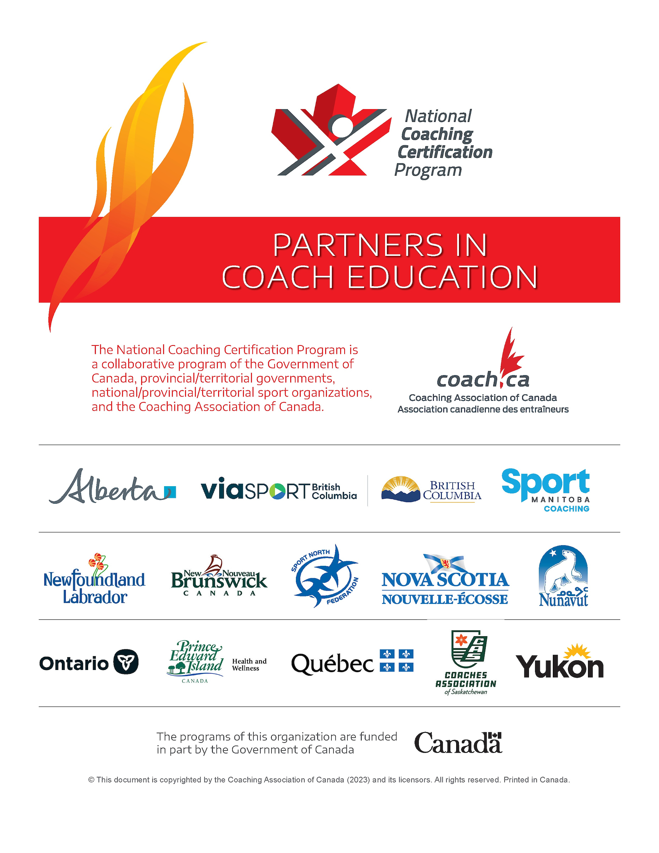

When adapting the NCCP Operations Manual…
Ensure this Partners Page is the most up-to-date version. All current NCCP logos and manual components are located in the PhotoShelter:
NCCP Manual Components / Composantes des manuels du PNCE | Coach.ca
Passcode to download images: CAC!2010
Table of contents

When adapting the NCCP Operations Manual… 2
When adapting the NCCP Operations Manual… 3
When adapting the NCCP Operations Manual… 8
1. <Insert National Sport Organization> and Coach Development 9
1.1 Mission, Vision and Values 9
When adapting the NCCP Operations Manual… 9
1.2 Partners in Coach Education 9
When adapting the NCCP Operations Manual… 11
2. The NCCP Model 12
2.1 NCCP Streams and Contexts 13
When adapting the NCCP Operations Manual… 16
2.2 Training versus Certification in the NCCP 17
3. Coach Development Model 18
When adapting the NCCP Operations Manual… 18
4. NCCP Training 24
When adapting the NCCP Operations Manual… 24
4.1 Sport Specific Training 24
4.2 Multi-sport Training 24
5. NCCP Evaluation and Certification 25
5.1 Objectives 25
When adapting the NCCP Operations Manual… 25
5.2 Recognition of Coaching Competence 25
When adapting the NCCP Operations Manual… 26
6. Coach Developers 27
6.1 Coach Developers Roles 28
6.2 Recruitment 29
When adapting the NCCP Operations Manual… 29
When adapting the NCCP Operations Manual… 30
6.3 How to become a Coach Developer 31
When adapting the NCCP Operations Manual… 33
When adapting the NCCP Operations Manual… 33
When adapting the NCCP Operations Manual… 34
When adapting the NCCP Operations Manual… 34
6.4 Retention and Recognition 34
When adapting the NCCP Operations Manual… 35
7. NCCP Administration 36
7.1 Responsibilities and Planning 36
7.2 Minimum Age Restrictions 37
When adapting the NCCP Operations Manual… 38
7.3 Multi-Sport Master Coach Developer Support to Sports 38
7.4 Appeals and Audits of Evaluations 39
When adapting the NCCP Operations Manual… 40
7.5 Business Model 40
When adapting the NCCP Operations Manual… 42
When adapting the NCCP Operations Manual… 43
7.6 Maintenance of Certification and Professional Development 43
When adapting the NCCP Operations Manual… 45
7.7 Quality Control 46
When adapting the NCCP Operations Manual… 46
7.8 Succession Planning 47
When adapting the NCCP Operations Manual… 48
8. Tools 49
8.1 NCCP Code of Ethics 49
8.2 NCCP <Insert Sport> Coach Developer Code of Conduct 51
When adapting the NCCP Operations Manual… 52
8.3 Template for Coach Developer Self-Nomination Letter 53
8.4 Template for Coach Developer Application Form 54
8.5 Template for Coach Developer Letter/Preliminary Worksheet 55
8.6 Template for Feedback Form 57
When adapting the NCCP Operations Manual… 59

The Collection, Use, and Disclosure of Personal Information
The Coaching Association of Canada collects your NCCP qualifications and personal information and shares it with all NCCP partners according to the privacy policy detailed at www.coach.ca. By participating in the NCCP you are providing consent for your information to be gathered and shared as detailed in the privacy policy. If you have any questions or would like to abstain from participating in the NCCP, please contact coach@coach.ca.

Purpose of this document
Launched in 1974 and delivered in partnership with the government of Canada, provincial/territorial governments, and national/provincial/territorial sport organizations, the National Coaching Certification Program (NCCP), gives coaches the confidence to succeed.
The Coaching Association of Canda (CAC) works with over 65 different National Sport Organizations, including <Insert National Sport Organization>, across Canada in the development of sport-specific NCCP training. Currently, there are over 850 workshops available at every level of sport – from 3-hour online introductory workshops for beginner coaches, to weekend workshops for intermediate coaches, to intensive two-year training programs for advanced coaches.
This <Insert Sport> NCCP Operations Manual contains guidelines and procedures for successful implementation of the NCCP. It is not intended to replace the NCCP Policies and Implementation Standards, nor does it serve as development guidelines.
Version Control
The following table outlines the history of this document and identifies any notable changes.
Revision Date | Revisions
2015/04/01 | Original document publication.
2016/05/11 | New multi-sport modules, 2016 version of Code of Ethics, and changes to Coach Developers section
2020/04/21 | New branding, 2020 version of Code of Ethics, changes to PTCR list, 2020 version of NCCP model, minimum age restriction, update MSM descriptions, addition of section 4.5
2025/10/07 | Updated Logos, Partners Page, NCCP Model, NCCP Code of Ethics, Coach Developer Pathway, NCCP Streams and Contexts definitions, Make Ethical Decisions naming convention; simplification and re-ordering of sections

When adapting the NCCP Operations Manual…
- Include any historical or introductory information specific to your sport and the NCCP here.
- Update the “Revision Date” to reflect the date of publication.
- With each revision of the original document, include notable changes.
- Delete this box when you have finished adapting the NCCP Operations Manual.

<Insert National Sport Organization> and Coach Development

Mission, Vision and Values

When adapting the NCCP Operations Manual…
- Insert the mission, vision, and values for your organization.
- Delete this box when you have finished adapting the NCCP Operations Manual.

Partners in Coach Education
The CAC, the provincial/territorial NCCP delivery agencies, the National Sport Organizations, and the federal-provincial/territorial governments are individually and collectively responsible to:
- Ensure that the NCCP and other coaching and sport leader development programs contribute to a safe and ethical sport experience in all contexts of participation;
- Ensure that the programs integrate into the Sport for Life’s framework and follow the principles of Long-term Development;
- Ensure that coaching and sport leader development programs are available in both French and English;
- Use best efforts to make the program accessible to all, including traditionally underrepresented and/or marginalized populations as referenced in the Canadian Sport Policy and the Federal-Provincial/Territorial Priorities for Collaborative Action;
- Endorse the value of competent coaches and support, along with other stakeholders, higher standards of coaching competencies and working conditions/environments for coaches;
- Actively participate in the resolution of any differences that put the integrity and continuity of the NCCP at risk.

Coaching Association of Canada (CAC)
The Coaching Association of Canada unites stakeholders and partners in its commitment to raising the skills and stature of coaches and ultimately expanding their reach and influence. Through its programs, the CAC empowers coaches with knowledge and skills, promotes ethics, fosters positive attitudes, builds competence, and increases the credibility and recognition of coaches.

Provincial/Territorial Coaching Representatives (Provincial/Territorial Coaching Representatives)
The Provincial/Territorial Coaching Representatives provide leadership, development, and support in delivering the NCCP.
- Alberta: Alberta Sport, Physical Activity and Recreation
- British Columbia: viaSport BC
- Manitoba: Sport Manitoba Coaching
- New Brunswick: Coach NB
- Newfoundland and Labrador: Sport Newfoundland and Labrador
- Northwest Territories: Sport North Federation
- Nova Scotia: Communities, Culture and Heritage – Communities, Sport, and Recreation Division
- Nunavut: Sport and Recreation Division
- Ontario: Coaches Association of Ontario
- Prince Edward Island: Sport PEI
- Quebec: SportsQuébec
- Saskatchewan: Coaches Association of Saskatchewan
- Yukon: Sport and Recreation, Department of Community Services, Government of Yukon

National Sport Organization
- <Insert National Sport Organization>

Provincial/Territorial Sport Organizations

When adapting the NCCP Operations Manual…
- Include information specific to your sport and the NCCP here. Try not to duplicate other information found in the manual.
- Under “Provincial/Territorial Sport Organizations” list your Provincial/Territorial Sport Organizations in alphabetical order.
- Provide a paragraph recognizing the contribution and value of the partners.
- List any additional formally recognized partners.
- Delete this box when you have finished adapting the NCCP Operations Manual.

The NCCP Model
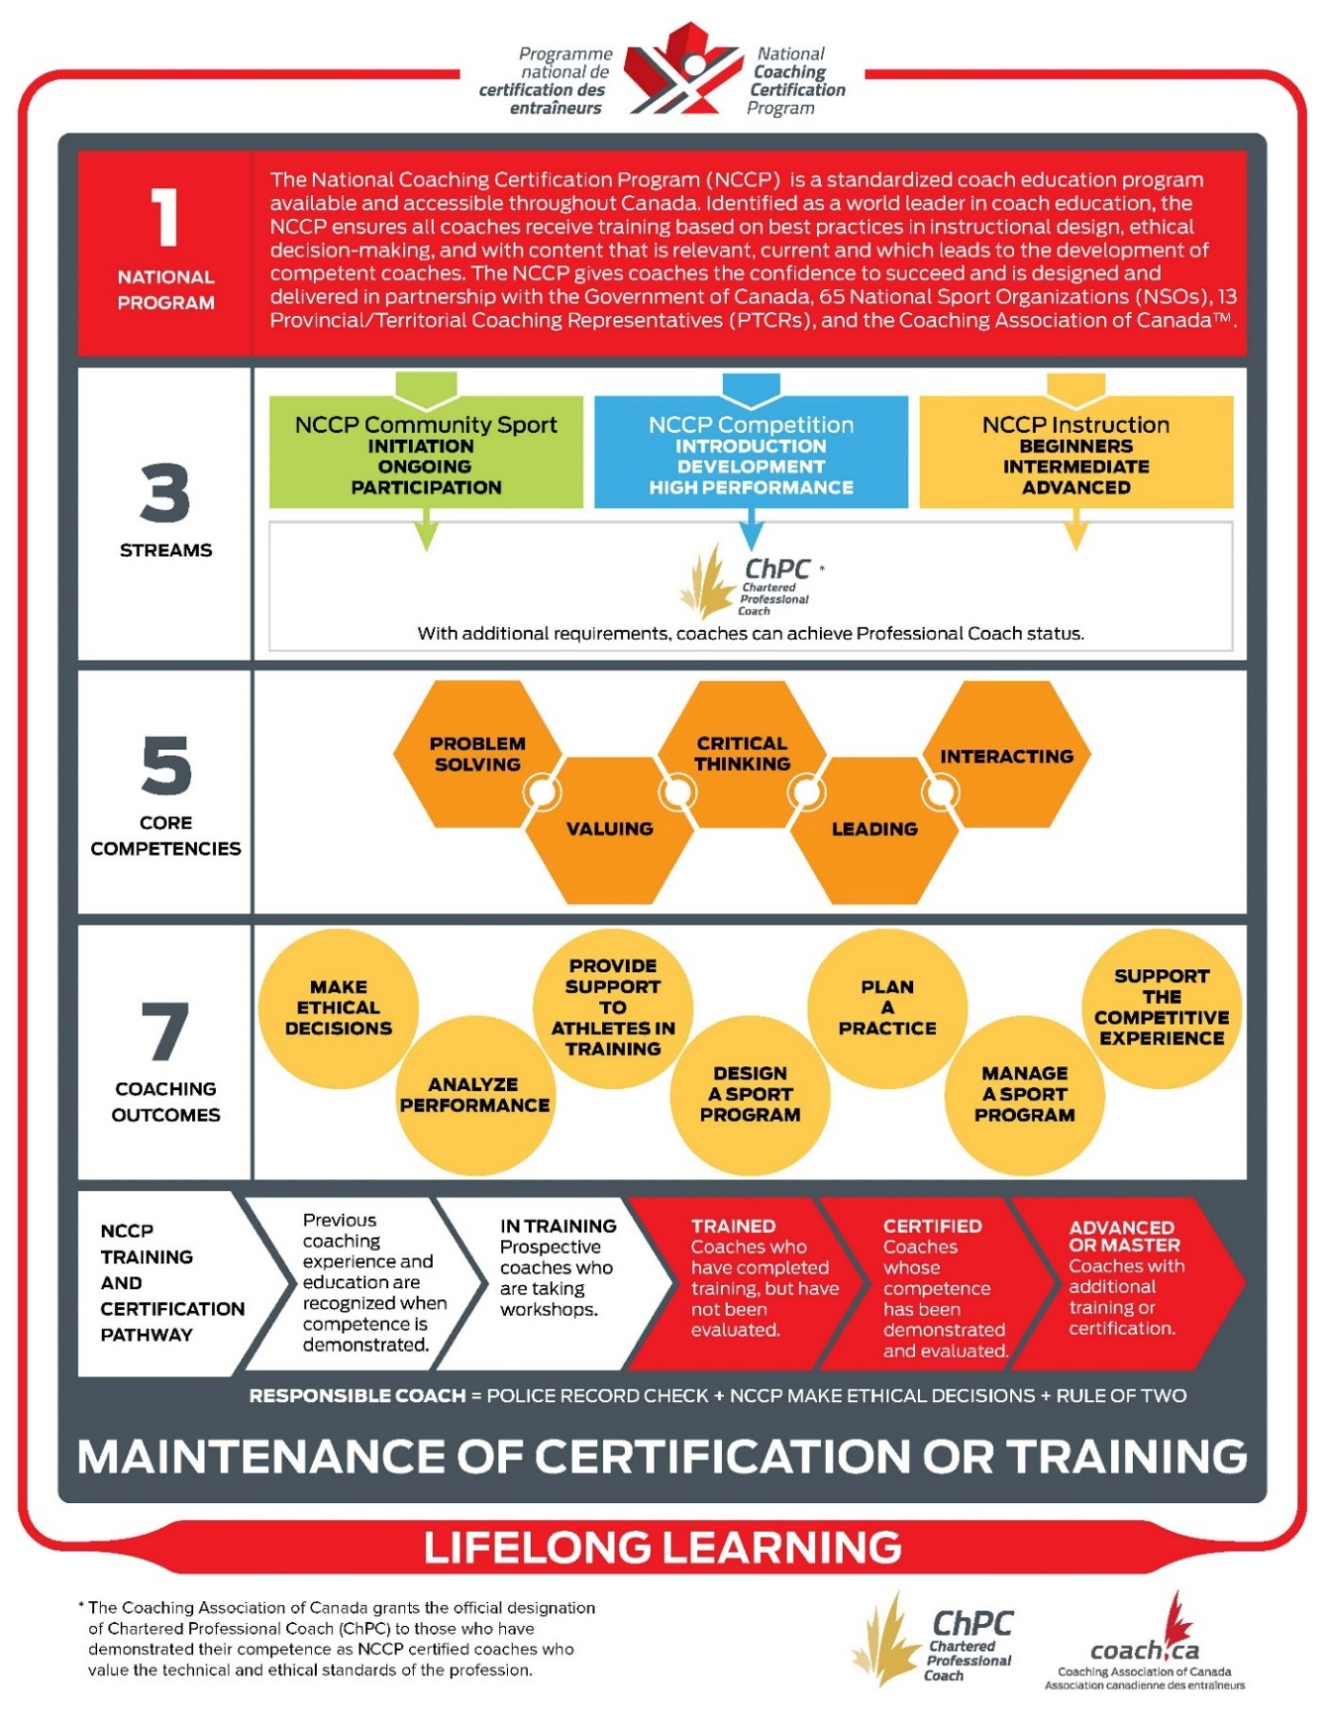

NCCP Streams and Contexts
The NCCP is comprised of three coaching streams. Within each NCCP Coaching stream are NCCP Coaching contexts, which align coaching activities with specific types of participants and their stage of development.
NCCP Stream |  | NCCP Context | Typical participants stage of development | Typical coach functions
Community Sport Coach |  | Community Sport – Initiation | Awareness, First involvement, Active Start, Fundamentals, Active for Life | Helping sport participants develop fundamental and basic sport capabilities.
Community Sport Coach |  | Community Sport – Ongoing | Active for Life | Helping sport participants develop capabilities for life-long sport and physical activity.
Competition Coach |  | Competition-Introduction | Learn to Train | Introducing participants to competitive sport - understanding basic rules, tactics, and strategy and refining basic sport capabilities.
Competition Coach |  | Competition-Development | Train to Train, Train to Compete | Introducing athletes to competitive sport performance with specialized and periodized training and competition plan
Competition Coach |  | Competition High-Performance | Train to Compete, Train to Win | Helping athletes refine advanced sport capabilities and preparing them for international level competitions.
Instructor |  | Instruction-Beginners | Awareness, First involvement, Active Start, Fundamentals, Active for Life | Teach basic skills to individuals with very little or no experience in the sport or the activity.
Instructor |  | Instruction - Intermediate | Learn to Train, Train to Train | Help participants refine basic skills, and to introduce a variety of more complex techniques.
Instructor |  | Instruction - Advanced | Train to Compete, Train to Win | Help participants refine advanced skills.


Community Sport
Many people in Canada become involved in coaching on a volunteer and short-term basis, particularly at the community level. The Canadian Sport System should not expect that these individuals can commit to long and expensive training and certification programs without first having the opportunity of experiencing a basic form of coaching and determining whether they wish to be involved more extensively into this sphere of activity.
However, basic training and, in certain sports, certification is necessary to ensure quality sport participation for all participants.
Community Sport coaching programs can be developed in two contexts:
- Community Sport – Initiation: Aimed at coaches working at the community level with either:
- young children at the Awareness and First involvement, Active Start or Fundamentals stages of development or;
- older participants being introduced to the sport, at the Awareness and First involvement stages of development (Long-Term Development - Sport for Life).
- Community Sport - Ongoing Participation: Aimed at coaches working at the community level with participants (adolescents, youth and/or adult) participating in sport and physical activities, with a predominantly recreational or health purpose (Active for life stage of development).


Competition Coach
Typical characteristics of coaches working in the “Competition” stream are:
- They work in a competitive environment where performance outcomes are emphasized
- They guide and support athletes in both training and competitive settings
- They aim to enhance athletes’ performance and long-term development
- They support athletes in their social, physical, mental and sport capabilities development
- They use sport as a tool for holistic individual growth
- They foster positive values and life skills through sport
- They create conditions whereby sport is a positive experience and the athlete’s self-esteem is enhanced
Programs for Competition coaches’ Training and Certification can be developed in three contexts, each reflecting the major objectives pertaining to the athlete’s development, as well as their proficiency level:
- Competition-Introduction: This type of coach will, for the most part, be working with children, pre-adolescents or adolescents, at the Learn to Train and early Train to Train stages of development. They will teach basic skills and tactics, and prepare athletes for local, regional and some provincial level competitions. Athletes will train on a seasonal or yearly basis to improve their general fitness level, and most of the training is expected to occur through the sport itself. Fun will be an important part of the athletes’ sport experience that will provide opportunities to teach values and develop social skills.
- Competition-Development: This type of coach will, for the most part, be working with adolescents and young adults at the Train to Train and Train to Compete stages of development. They will help athletes refine basic skills and tactics, teach more advanced skills and tactics, and prepare athletes for provincial, national and sometimes international level competitions. Athletes will train several times a week on a seasonal or annual basis to improve performance. Although having a good time will remain an important part of the athletes’ sport experience, the outcome of competitions will be important as the athletes may have to meet pre-determined performance standards. Event/discipline specialization and fitness will also be important at this stage. Sport will provide an opportunity to teach values and ethics and refine social skills.
- Competition High-Performance: This type of coach will, for the most part, be working with adults below the age of 35-40, at the Train to Compete and Train to Win stages of development. They will help athletes refine advanced or special skills and tactics and prepare them for international level competitions. Athletes will perform a high volume of specialized training on annual basis to improve or maintain performance. Although having a good time will remain an important part of the athletes’ sport experience, the outcome of competitions will be very important. The athletes will endeavor to reach their full potential by attaining world-class performance levels. Sport will provide an opportunity to implement values and demonstrate social skills and ethical sense.


Instruction
Many people in Canada are involved in sport as instructors. In the NCCP, the characteristics of coaches working as instructors are the following:
- Their primary responsibility is to teach sport-specific skills.
- They intervene with participants of various proficiency levels.
- They intervene primarily in a non-competitive context.
Programs for Instructors’ Training and Certification can be developed in three streams:

- Instruction-Beginners Context: The instructor is expected to teach basic skills to individuals with very little or no experience in the sport or the activity. They deal with a limited number of participants and focus on the fundamentals of the activity with an emphasis on safety, where appropriate. They are restricted to implementing a “pre-packaged program” developed by competent authorities within the sport and required to be supervised by a more senior instructor for a set period.
- Instruction - Intermediate Context: The instructor is expected to help participants refine basic skills, and to introduce a variety of more complex techniques to individuals who already have some experience in the sport and who exhibit a fair degree of proficiency in the activity. They provide more “customized” instruction, based on the individual performance characteristics of each participant, and are expected to manage bigger groups. Where necessary, they refer to a more senior instructor to address more complex problems. An Instruction-Intermediate candidate is expected to be fairly knowledgeable in all matters related to the selection and adjustment of equipment and may be required to supervise some coaches working at the Beginner level.
- Instruction - Advanced Context: The instructor is expected to help participants refine advanced skills, and to provide extensive “customized” instruction, including the development of new and innovative drills to address highly individualized problems. The advanced instructor is expected to supervise coaches working at the Beginner or Intermediate levels and may be required to be competent in performance-related areas other than equipment, skills and techniques.

When adapting the NCCP Operations Manual…
- Remove any contexts or levels that you will not have for your sport.
- Add sport-specific context names and descriptions.
- Delete this box when you have finished adapting the NCCP Operations Manual.

Training versus Certification in the NCCP
The NCCP model distinguishes between training and certification. Coaches can participate in training opportunities to acquire or refine the skills and knowledge required for a particular coaching context (i.e. Competition – Introduction) as defined by the sport and be considered “trained”.
To become “certified” in a coaching context, coaches must be evaluated on their demonstrated ability to perform within that context in areas such as program design, practice planning, performance analysis, program management, ethical coaching, support to participants during training, and support to participants in competition.
Certified coaches enjoy the credibility of the sporting community and of the athletes they coach because they have been observed and evaluated “doing” what is required of them as a competent coach in their sport. They are recognized as meeting or exceeding the high standards embraced by more than 65 national sport organizations in Canada. Fostering confidence at all levels of sport, certification is a benefit shared by parents, athletes, sport organizations, and our communities.
NCCP coaches are described as follows:
- In Training – when they have completed some of the required training for a context;
- Trained – when they have completed all required training for a context;
- Certified – when they have completed all evaluation requirements for a context.

Coach Development Model

When adapting the NCCP Operations Manual…
- Insert the Coach Development Model for your sport.
- Insert information about the alignment of the NCCP and long-term participant/athlete development in your sport.
- If possible, this should include a visual pathway outlining the participants/athletes’ stages of development.
- Insert specific Coach Pathways for each context of your sport, either using the graphics below, or the PowerPoint versions that can be found in the General parters protected area.
- Delete any pathway headings you do not have in your sport.
- Delete this box when you have finished adapting the NCCP Operations Manual.

The Community - Initiation Coach Pathway
LTD stage(s):
- Awareness
- First involvement
- Active Start
- FUNdamentals
In Training
Trained
- NCCP Make Ethical Decisions
- NCCP Coach initiation in Sport
- NCCP Emergency Action Plan
- NCCP Sport Workshop

The Community - Ongoing Coach Pathway
LTD stage(s):
- Active for life
In Training
Trained
- NCCP Make Ethical Decisions
- NCCP Coach initiation in Sport
- NCCP Emergency Action Plan
- NCCP Sport Workshop

The Competition - Introduction Coach Pathway

LTD stage(s):
- Learn to Train
- Train to Train

- NCCP Design a Basic Sport Program
- NCCP Manage a Sport Program
- NCCP Leading Drug-Free Sport
- NCCP Managing Conflict
- NCCP Leading Drug-Free Sport
- NCCP Managing Conflict Online Evaluation
- Seasonal/Yearly Training Plan
- Athlete progress reports
- Observation in Competition

Advanced Certified
- NCCP Make Ethical Decisions
- Practice Plan
- Emergency Action Plan
- Observation in Training

Certified
Maintenance of Certification
(20 points / 5 years
- NCCP Make Ethical Decisions
- Emergency Action Plan
- NCCP Planning a Practice
- NCCP Teaching and Learning
- NCCP Basic Mental Skills
- NCCP Sport Nutrition
- NCCP Sport Workshop
In Training
Trained

The Competition - Development Coach Pathway
LTD Stages
Train to Compete
Train to Win

Competitions
National Championships
NextGen International Events

NCCP Advanced Coaching Diploma
CDAG Evaluation
Advanced Certified
LTD stage(s):
- Train to Train
- Train to
Compete

Competitions
Provincial and
National
Competitions
- NCCP Make Ethical Decisions
- NCCP Emergency Action Plan
- NCCP Advanced Practice Planning
- NCCP Coaching and Leading Effectively
- NCCP Developing Athletic Abilities
- NCCP Manage a Sport Program
- NCCP Managing Conflict
- NCCP Performance Planning
- NCCP Prevention and Recovery
- NCCP Sport Workshop
In Training
Trained

- NCCP Make Ethical Decisions
- NCCP Managing Conflict Online Evaluation
- NCCP Leading Drug-Free Sport eLearning
- Pre-season meeting notes
- Yearly Training Plan
- 3 Microcycles
- Emergency Action Plan
- Practice Plan
- Observation in Training
- Event Information Package
- Observation in Competititon
Certified
Maintenance of Certification
(30 points / 5 years

The High-Performance Coach Pathway
Maintenance of Certification
(30 points / 5 years
Individual Action Plan
Final Evaluation
Certified
Program entry & Competencies assessment
LTD stage(s):
- Train to Win
Environment
- National Team

The Instructor - Beginner Pathway

LTD stage(s):
- Active Start
- Fundamentals
Environment
- School
- Club

- NCCP Planning a Practice
- NCCP Design a Basic Sport Program
- NCCP Manage a Sport Program
- Lesson Plan
- Multi-week lesson plans/Logbook
- 2 Participant Progress Reports
Advanced Certified
- NCCP Make Ethical Decisions
- Emergency Action Plan
- Observation in Training

Certified
Maintenance of Certification
(10 points / 5 years
- NCCP Make Ethical Decisions
- Emergency Action Plan
- NCCP Teaching and Learning
- NCCP Sport Workshop
In Training
Trained

The Instructor - Intermediate Pathway

LTD stage(s):
- Learn to Train
- Train to Train

- NCCP Sport Workshop
- NCCP Design a Basic Sport Program
- 2 Participant Progress Reports
- Administrative Logbook
- Multi-week lesson plans/Logbook
Advanced Certified
- NCCP Make Ethical Decisions
- Emergency Action Plan
- Lesson Plan
- Observation in Training

Certified
Maintenance of Certification
(20 points / 5 years
- NCCP Make Ethical Decisions
- Emergency Action Plan
- NCCP Teaching and Learning
- NCCP Planning a Practice
- NCCP Sport Workshop
In Training
Trained

The Instructor - Advanced Pathway

LTD stage(s):
- Train to
Compete
- Train to Win
- Active for Life

- NCCP Design a Basic Sport Program
- Multi-week lesson plans/Logbook
Advanced Certified
- NCCP Make Ethical Decisions
- Emergency Action Plan
- Lesson Plan
- Observation in Training
- Administrative Logbook
- 2 Participant Progress Reports

Certified
Maintenance of Certification
(20 points / 5 years
- NCCP Make Ethical Decisions
- Emergency Action Plan
- NCCP Teaching and Learning
- NCCP Planning a Practice
- NCCP Sport Workshop
In Training
Trained

NCCP Training

When adapting the NCCP Operations Manual…
- Include the information specific to your sport-specific training modules.
- Include information about where to register
- Delete this box when you have finished adapting the NCCP Operations Manual.

Sport Specific Training

Multi-sport Training
Multi-sport modules consist of generic coach educational components that meet NCCP standards and provide training toward certain outcomes and criteria. Coaches take the multi-sport modules from a multi-sport environment. Provincial/Territorial Coaching Representatives are responsible for delivering the NCCP multi-sport modules within their respective jurisdictions. For more information please visit: Training Modules | Coaching Association of Canada | Association canadienne des entraîneurs

NCCP Evaluation and Certification

Objectives
Evaluation in the NCCP is the process used to determine whether coaches meet NCCP context-specific coaching standards for certification. The evidence in NCCP evaluations consists of observable coaching behaviour that is used to determine whether a coach meets a given criterion. It is preceded by NCCP training or relevant experience.
Coaches seeking certification must contact their Provincial/Territorial sport organization.

When adapting the NCCP Operations Manual…
- Include information about where to register for evaluation
- Delete this box when you have finished adapting the NCCP Operations Manual.

Recognition of Coaching Competence
The NCCP is a competency-based program based on coaching outcomes, meaning the NCCP is a program that certifies coaches based on proven abilities to “DO” certain things deemed important to meet the needs of the participants they coach. The NCCP is competency based, and as a result certification is based upon what a coach can demonstrate, not the training they may or may not have undergone.
Coaches must go through the evaluation process for the context in which they are coaching. Evaluation must include the entire evaluation process for the context in which the coach is being certified (including online multi-sport evaluations). This ensures the coach can demonstrate the required competencies for the context and removes the need for the National Sport Organization or other partners to “judge” the relevance or rigor of the many different international programs that exist.
Coaches do not receive credit for “training” modules that they do not complete but will be able to achieve “certified” status upon a successful evaluation. This only applies in contexts where certified status is available to coaches. There is no such thing as “equivalency”.
This respects and recognizes current coaching competence, which includes Canadian coaches with significant coaching experience or related background, and foreign coaches with approved training and certification.
To pursue recognition of coaching competence through…

When adapting the NCCP Operations Manual…
- Include the process for coaches to demonstrate competency in each context.
- Delete this box when you have finished adapting the NCCP Operations Manual.

Coach Developers
Who coaches the coaches? NCCP Coach Developers do!
According to the International Council for Coaching Excellence (ICCE), Coach Developers “are not simply experienced coaches or transmitters of coaching knowledge – they are trained to develop, support, and challenge coaches to go on honing and improving their knowledge and skills in order to provide positive and effective sport experiences for all participants.” In short, Coach Developers need to be experts in learning, as well as experts in coaching.
NCCP Coach Developers include Learning Facilitators, Coach Evaluators, and Master Coach Developers.
All Coach Developers should complete the training and certification pathway as a measure of system quality assurance.
The Qualified to Deliver list on a Coach Developer transcript in the Locker indicates the module(s) a Coach Developer can deliver independently. This means the Coach Developer has achieved a trained or certified status.
A trained Coach Developer status requires the following:
- NCCP Make Ethical Decisions
- Core Training, of the Coach Developer outcomes specific to the role (Learning Facilitator, Coach Evaluator or Master Coach Developer)
- Content-Specific Training for the module(s) content a Coach Developer is being trained to deliver
- A Co-Delivery, of the Coach Developer outcomes specific to the role (Learning Facilitator, Coach Evaluator or Master Coach Developer)
A certified Coach Developer status requires the following:
- An Evaluation of the Coach Developer outcomes specific to the role (Learning Facilitator, Coach Evaluator, Master Coach Developer)
Once a Coach Developer has achieved a trained or certified status in a role, only Content-Specific Training needs to be completed to have additional modules added to their Qualified to Deliver list. Only one co-delivery is required per role.

Coach Developers Roles

Learning Facilitator
Every NCCP workshop is led by a trained Learning Facilitator who has undergone a standardized training process. Learning Facilitators are crucial to the development of skilled, knowledgeable coaches who are then able to develop safer, happier athletes/participants.
Learning-Facilitators act as ambassadors of the NCCP. Their role is to effectively facilitate sessions that result in the development of coaches who can demonstrate their abilities and meet the standards established for certification. A Learning Facilitator should have the appropriate knowledge, skills, and attitudes to facilitate workshops using the competency-based approach.

Coach Evaluator
A Coach Evaluator’s role is to contribute to the development of coaches through assessment, evaluation, debriefing, and follow-up with coaches trying to achieve Certified status. Coach Evaluators are experts in the observation process and have in-depth knowledge of the outcomes, criteria, and evidence that comprise the evaluation tools establishing the NCCP standards for coaches of a particular sport context.
Coach Evaluators act as ambassadors of the NCCP and as a resource to coaches seeking to augment and validate their coaching abilities.

Master Coach Developer
The role of the Master Coach Developer is to train, to evaluate, to support, and to mentor Coach Developers, i.e. Learning Facilitators, Coach Evaluators, and other Master Coach Developers. In addition, Master Coach Developers play a key role in promoting the NCCP. Their duties usually include:
- Helping with selection of the Learning Facilitators, Coach Evaluators, and other Master Coach Developers
- Training of the Learning Facilitators, Coach Evaluators, and other Master Coach Developers
- Evaluation of the Learning Facilitators, Coach Evaluators, and other Master Coach Developers
- Mentoring of the Learning Facilitators, Coach Evaluators, and other Master Coach Developers
Master Coach Developers must possess adequate knowledge and expertise in facilitation to assist in training Coach Developers and to lead workshops and professional development experiences for Coach Developers.
It is expected that Master Coach Developers will have more responsibility in a supportive role with Coach Developers during workshops, evaluations, and in Coach Developer development. Master Coach Developers should be willing and able to lend support to Coach Developers, program administrators, and delivery host agencies.

Recruitment
There are two ways to become a Coach Developer candidate:
- Master Coach Developers, Provincial/Territorial Sport Organizations, and National Sport Organizations (National Sport Organizations) can identify Coach Developer candidates.
- Individuals can nominate themselves.
The <Insert National Sport Organization> in conjunction with the Provincial/Territorial Sport Organization's ensure that the needs are being shared and planned for on an annual. The <Insert National Sport Organization> will provide leadership in ensuring that each province always has the support they need to train and certify their coaches.
The pool of Coach Developers should balance the regional training requirements for the sport with the need to have appropriate representation of all regions in Canada, in both official languages. Many candidates are coaches who are already involved in the NCCP or individuals with backgrounds in physical education, kinesiology, or similar areas of study.
Individuals who nominate themselves are sent the template for the Letter of Self-nomination and are asked to fill in this letter and submit it to their Provincial/Territorial Sport Organization or National Sport Organization, along with their resume.

When adapting the NCCP Operations Manual…
- Describe the self-nomination process
- Describe succession planning for Coach Developers in your sport.
- Delete this box when you have finished adapting the NCCP Operations Manual.

Identification and Selection of Coach Developers
The competencies of the Coach Developers are clearly indicated in the Evaluation Tools provided on coach.ca for each role. All Coach Developers are expected to adhere to the NCCP Code of Ethics and demonstrate a desire to see the coach certification system as well as the sport grow. Coach Developers must have credibility or social capital, knowledge of sport and the sport system, they must manage relationships, focus on the learner, manage themselves, and continue their own personal learning to positively affect coach development (Barz, Côté & Martin,2022). Specific characteristics expected for the different Coach Developers roles are outlined in the next table.
NCCP Coach Developers Characteristics
Coach Evaluator | - A minimum of 3 years of coaching experience in the context in which evaluation takes place.  - Time and energy to commit to the evaluation process.  - Proven guiding and facilitation skills.  - Ability to be critically reflective and ask questions.  - Ability to listen actively to the candidate.
Learning-Facilitator | - Trained or certified in the context they are delivering in.  - Good communicators: speak clearly and communicate professionally.  - Good presenter: comfortable presenting in front of a group, well spoken, able to keep presentations to time limits, and able to adapt to questions and changes.  - Good facilitator: can facilitate discussions, actively listen, evoke participation, and move discussions along when need be.  - Good organizers: well prepared, organized, and professional.
Master Coach Developer | - Have the characteristics expected from Learning Facilitators and Coach Evaluators.  - Have five years of experience as a Learning Facilitator and/or Coach Evaluator.  - Are Certified as a Learning Facilitator and/or Coach Evaluator.

When adapting the NCCP Operations Manual…
- Describe the sport-specific background or skillset that is required for each role.
- Delete this box when you have finished adapting the NCCP Operations Manual.

How to become a Coach Developer
All Coach Developers must complete NCCP Make Ethical Decisions and the following steps:
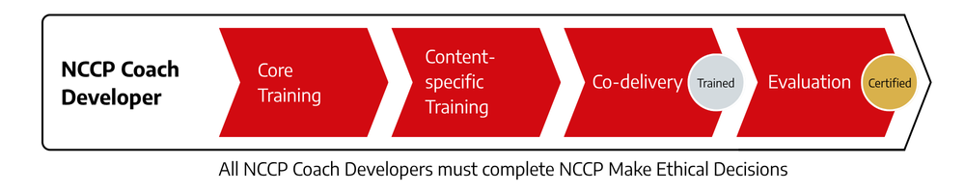

Core Training
Core Training is a mandatory component of training for each Coach Developer role. It is recommended that Core Training is completed prior to Content-specific Training and can be accessed through the Provincial/Territorial Coaching Representative in each province or territory. The table below identifies all components of the Core Training for each role.
Core Training components
Core Training for Coach Evaluators | - Overview of the workshop and the NCCP  - The certification process  - Learning to debrief  - Action planning
Core Training for Learning Facilitator | - Overview of the workshop and the NCCP  - Functions of a Learning Facilitator  - Elements of an effective learning activity  - Stages of group development  - Nature of the group
Core Training for Master Coach Developers | - Core Training for Learning Facilitators  - Core Training for Coach Evaluators  - Core Training for Master Coach Developers

Content-specific Training
Content-specific Training is a mandatory component of training for Learning Facilitators. It can be accessed through the Provincial/Territorial Sport Organizations of the sport. The table below identifies all Content-Specific Training components for each role.
Content-Specific Training components
Coach Evaluators | - Evaluation methodology and tools  - Using evaluation tools for formal observation  - Using evaluation tools for portfolio review  - Administration and logistics  - Review and sign the NCCP Coach Developer Code of Conduct
Learning Facilitator | - Review and micro-facilitation of module content  - Administration of the module  - Review and signature of the NCCP Coach Developer Code of Conduct  - Review Learning Facilitator evaluation standards and the evaluation process
Master Coach Developers | - Administration of NCCP programs  - Leadership within the NCCP  - Micro-facilitation of Coach Developer training  - Review Master Coach Developer evaluation standards  - Review and sign the NCCP Coach Developer Code of Conduct

Content-Specific Training for Coach Evaluator is a <insert number > day training…

Content-Specific Training for Learning-Facilitator is a <insert number > day training…

Content-Specific Training for Master Coach Developer is a <insert number > day training…

When adapting the NCCP Operations Manual…
- Describe specifically how a Coach Developer can sign-up for a content-specific training
- Describe the specific components and logistics of each training
- Identify who the governing body is who oversees this role (i.e. National Sport Organization, Provincial/Territorial Sport Organization, etc.) and where a potential Coach Developer goes for information.
- Delete this box when you have finished adapting the NCCP Operations Manual.

Co-Delivery
Informal co-delivery has long been a part of successful coaching. Less experienced coaches have acquired essential coaching knowledge and skills by watching more experienced coaches in action, performing similar coaching tasks, and getting feedback from their more experienced colleagues. All coach developers must co-deliver as part of their training. This step is part of training and therefore the person being trained will not be paid. A Coach Developer candidate may be required to co-facilitate a workshop a number of times before facilitating a workshop on their own. Successful co-delivery is required only once per role and involves:
- Prebrief
- Successful Co-facilitation
- Debrief
Coach Evaluators must co-evaluate with an experienced Coach Developer prior to performing an evaluation on their own.
Learning Facilitators must co-facilitate a workshop with an experienced Coach Developer prior to facilitating a workshop on their own.
Master Coach Developers must co-deliver Learning Facilitator training or Coach Evaluator training with an experienced Coach Developer prior to training or evaluating other Coach Developers on their own.

When adapting the NCCP Operations Manual…
- Indicate any sport-specific co-delivery requirements
- Describe the process for a Coach Developer to sign-up for co-delivery
- Delete this box when you have finished adapting the NCCP Operations Manual.

Evaluation
All Coach Developers must be evaluated to become certified. The process involves:
- Prebrief
- Formal observation
- Debrief
- Action plan
- Final recommendation

When adapting the NCCP Operations Manual…
- Indicate any sport-specific evaluation requirements.
- Describe the process for a Coach Developer to sign-up for evaluation
- Delete this box when you have finished adapting the NCCP Operations Manual.

Lifelong Learning and Maintenance of Certification
All Coach Developers are required to attain 20 Professional Development points over 5 years to maintain their certification.

When adapting the NCCP Operations Manual…
- Indicate any sport-specific Maintenance of Certification requirements.
- Delete this box when you have finished adapting the NCCP Operations Manual.

Retention and Recognition
In <Insert Sport>, we recognize how critical the Coach Developer role is. Specific factors have been identified to help retain Coach Developers:
- Belonging
- Feeling that the learning culture aligns with their own
- Supportive relationships from the organization
- Opportunities to learn from other experienced Coach Developers in the workforce
- Opportunities to regularly contribute to coach development
- Alignment with organizational values and actions
In this perspective, the following strategies are used by <Insert National Sport Organization> to recognize Coach Developers value and retain their expertise.

The Provincial/Territorial Sport Organizations are responsible for…

When adapting the NCCP Operations Manual…
- Identify specific roles and responsibilities of each of the key groups (National Sport Organization, Provincial/Territorial Sport Organizations) in your sport.
- Describe recruitment, retention, and recognition for your sport, specific to the areas of Coach Developers.
- Delete this box when you have finished adapting the NCCP Operations Manual.

NCCP Administration

Responsibilities and Planning

National Sport Organization

Provincial/Territorial Sport Organizations

Local Sport Organizations

The Locker (the NCCP Database)
The Locker is the central location to easily access, manage and maintain your coach training and records. It can track, and time stamp all coach training and activities. That is why each user has a unique identification number (NCCP number).
All course and evaluation records are maintained electronically through the “Locker” which is a database established and maintained by the CAC. Each user must complete the Locker training that is provided by CAC and are responsible for entering their own courses into the Locker within two weeks following the course.
The NCCP Locker protocols are as follows:
- The Host Organization is responsible for Event Set-Up, Participant Registration, and submissions for approval.
- PSO approval
- National Sport Organization approval
- CAC final approval
To be respectful of our coaches who are working to advance their training and certification, it is important to submit event information as quickly as possible after each course. This will ensure that the CAC receives the appropriate information in a timely manner and that coaches are credited appropriately.
To ensure that approvals can be provided in a timely manner at each level, it is incumbent of the Host organization to ensure that all events are fully completed with all

of the relevant information included (i.e. Coach date of birth, email address, etc. The CAC will not accept incomplete events in the Locker.)

Minimum Age Restrictions
The NCCP Policy and Implementation Standards document indicates that the Policy on Minimum Age is as follows:
10.2. Policy Statement
10.2.1. The minimum age for the designation for a coach as NCCP “Certified” is 16 years of age.
10.2.2. Persons younger than 16 and older than 14 may enroll in and complete NCCP or NCCP qualifying education opportunities, where a National Sport Organization:
a) Plans to offer NCCP or NCCP qualifying development opportunities to persons younger than 16 years of age;
b) Agrees to provide these opportunities within the framework of the NCCP.
c) Agrees to maintain the records on the NCCP Database.
10.2.3. The Provincial/Territorial government or designated delivery agency may authorize enrolment in multi-sport modules.
10.2.4. Any person younger than 16 and older than 14 will be designated on the CAC Database with an underage status indicator.
10.3. Implementation Standards
10.3.1. Authority
The CAC is responsible for:
- Maintaining the records of persons younger than 16 and ensuring the roll-over to the appropriate status indicator upon their 16th birthday.
- Informing and educating all partners on the possible use and application of the underage status indicator.
National Sport Organizations are responsible for:
- Determining whether to allow 14- and 15-year-olds to access sport-specific NCCP events.
- Publicly communicating their position on the participation of 14- and 15-year-olds in sport-specific NCCP events on their websites.
Provincial/Territorial Delivery Agencies are responsible for:
- Determining whether to allow 14- and 15-year-olds to access multi-sport NCCP events.
- Publicly displaying their position on the participation of individuals under the age of 16 in the multi-sport modules on their websites.
- Notifying the CAC of their position.

When adapting the NCCP Operations Manual…
- Indicate what your policy is on minimum age restriction to access your National Sport Organization sport specific NCCP training.
- Delete this box when you have finished adapting the NCCP Operations Manual.

Multi-Sport Master Coach Developer Support to Sports
The following strategies are subject to National Sport Organization approval.
Sports are responsible for certifying coaches and Coach Developers. However, capacity can be enhanced through a partnership with the Provincial/Territorial Coaching Representatives multi-sport Master Coach Developers. This includes:
Co-Evaluation of coaches
- Ranging from 10:90% or 90:10%, anywhere in between for Sport and Multi-sport coach evaluator. There is no option for 100% evaluation through multi-sport. The Provincial/Territorial Coaching Representative role is to add value to sport-specific Coach Evaluation, not replace it.
Coach Developer Evaluations
- Evaluations of Learning Facilitators – Including a pre-brief, on site observation, debrief and action plan.
- Evaluations of Coach Evaluators – Including collecting, marking, debriefing the coach evaluator’s portfolio, and creating an action plan. On site observation is optional.
- Evaluations of Master Coach Developers – Including collecting, marking, debriefing the Master Coach Developer’s portfolio, and creating an action plan. On site observation is optional.
Coach Developer Mentorship
- General support and guidance from a Master Coach Developer to assist Coach Developers excel in their roles. This type of support can take many forms, including supporting sport specific content training delivery.

Collaborative Process
The collaborative process for Multi-Sport Coach Developer support will be different in every Province/Territory and sport depending on existing capacity and expertise. However, the first step is always for the National Sport Organization and/or the Provincial/Territorial Sport Organization to request support from the Provincial/Territorial Coaching Representative of the jurisdiction in which the support would take place. From there, all parties collaborate to reach the identified outcomes. The National Sport Organization and/or Provincial/Territorial Sport Organization are responsible to then process the event in the Locker.

Funding Implications
National Sport Organizations and/or Provincial/Territorial Sport Organizations are responsible for funding and covering the fees of the Provincial/Territorial Coaching Representative Master Coach Developers.

Appeals and Audits of Evaluations
Coaches and Coach Developers can appeal an unsuccessful evaluation.
It is recommended that Master Coach Developers complete an audit of coach evaluations on a regular schedule (e.g., every two years).
Audits and appeals must be submitted to the <Insert National Sport Organization or Provincial/Territorial Sport Organization> for review by a technical committee including:
- at least one Coach Evaluator or Master Coach Developer for coach evaluations
- at least one Master Coach Developer for Coach Developer evaluations
Documentation for an audit and appeal must include the following:
- A recording of the candidate’s delivery, or all templates used during the observation.
- All documentation related to the formal evaluation(s), debriefing procedure and action plan.
- The candidate portfolio with the marking template, as applicable.

Upon completing the review, a report is provided outlining the critical factors in the evaluation process that can be improved or required by the candidate or Coach Developer.
If an appeal is unsuccessful, the candidate may need to re-engage in the evaluation process or complete specific areas for improvement. If another formal observation is warranted, then it must be completed with a different Coach Developer and include the payment of designated fees. The National Sport Organization must provide the coach with an alternative Coach Developer.

When adapting the NCCP Operations Manual…
- Adapt the above to reflect the process applicable to your sport
- Include the cost associated to launch an appeal process
- Delete this box when you have finished adapting the NCCP Operations Manual.

Business Model

Communication
Section to be updated by the CAC

Identification and Credit
Section to be updated by the CAC

When adapting the NCCP Operations Manual…
- Do not delete any of the information provided.
- You may add additional communication guidelines for your sport.
- Delete this box when you have finished adapting the NCCP Operations Manual.

NCCP administration fees
The following outlines how the <Insert National Sport Organization> collects administration fees from Provincial/Territorial Sport Organizations to support NCCP development and maintenance.

Workshop fees
The following outlines the recommended workshop and evaluation registration fees.

Payment and Honoraria of Coach Developers
The following outlines the recommended guidelines regarding the payment of Coach Developers.

When adapting the NCCP Operations Manual…
- Include all required detail for the business operations of your sport.
- Include any additional requirements for the Business Model for your sport.
- While fee structure is often the responsibility of the Provincial/Territorial Sport Organization or Local Sport Organization, it is recommended that the National Sport Organization provide a fee range to provide guidelines. Ensure specifics are included for all contexts and all Coach Developer roles (if there is a different in honorarium or fees).
- Insert fee schedule, including per diem and travel, specific to your sport Coach Developers.
- Delete this box when you have finished adapting the NCCP Operations Manual.

Maintenance of Certification and Professional Development
The Coaching Association of Canada and its partners recognize the value of having certified NCCP coaches that are engaged in Professional Development programs which reinforce the values of lifelong learning and sharing amongst the coaching community.
For NCCP coaches to maintain their certified status, they will be required to obtain Professional Development points. Professional Development points can be earned through a multitude of activities that coaches already participate in, including National and Provincial/Territorial Sport Organization conferences and workshops, eLearning modules, NCCP workshops, coach mentorship programs, and active coaching. In most cases, coaches are already earning their required Professional Development points – Maintenance of Certification Status is simply the introduction of tracking these points and recognizing coaches for their efforts.
Maintenance of certification is essential to:
- Ensuring coaches stay current with new coaching practices and knowledge;
- Maintaining the integrity of the NCCP;
- Maintaining consistency with the standards of other professions;
- Reinforcing the values of lifelong learning and continuous improvement.
Certification within the NCCP shall be valid for a maximum period. The concept of “lifespan of NCCP certification” shall apply to coaches who:
- Are already certified according to the standards of the Levels-NCCP.
- Are certified according to the standards of the Levels-NCCP while it is still in effect.
- Are certified according to the standards of an NCCP context’s core certification and gradations.
Maintenance of certification must be based on active coaching and professional development.
Minimum Professional Development credits required based on the period for renewal of certification
Context  (includes any gradation) | 5 years | 4 years | 3 years | 2 years | 1 year
Community Sport  Instruction – Beginners | 10 points | 8 points | 6 points | 4 points | 2 points
Competition – Introduction  Instruction – Intermediate Performers  Instruction – Advanced Performers | 20 points | 16 points | 12 points | 8 points | 4 points
Competition – Development | 30 points | 24 points | 18 points | 12 points | 6 points

All Certified Coach Developers are required to attain 20 Professional Development points over 5 years to maintain their certification.
Professional development opportunities and points allocations for Multisport activity
Active Category | Points | Limitations
NCCP activity | 5 points/training module or evaluation event | No maximum or minimum
Non-NCCP activity | 1 point/hour of activity up to 3 points maximum | To a maximum of 50% of the required Professional Development credit for the context in a certification renewal period

Professional development opportunities and points allocations for sport specific activity
Active Category | Points | Limitations
Active Coaching | 1 point/year for every season coached  OR  1 point/year for learning Facilitator or Evaluator activity | To a maximum number of points equal to the number of years of the certification renewal period, e.g. 3 points, if certification period is 3 years
NCCP Activity | 5 points/training module or evaluation event | No maximum or minimum
Non-NCCP Activity | 1 point/hour of activity up to 3 hours maximum | No minimum or maximum
Coach self-directed activity | 3 points for the valid certification period | Maximum of 3 points for certification renewal period
Re-evaluation in context | 100% of the points required for Professional Development credit in the context | No other Professional Development is required if coach chooses re-evaluation

When adapting the NCCP Operations Manual…
- Highlight or emphasize the Professional Development credits required for your sport only. You may delete the columns of the years not applicable, and the contexts that are not applicable.
- Include any additional requirements for maintenance of certification.
- Delete this box when you have finished adapting the NCCP Operations Manual.

Quality Control

Program Monitoring and Evaluation
The following quality control mechanisms are in place to ensure the NCCP program remains current and of the highest standard possible:
- Coach Developers are carefully screened and selected based on their capabilities and experience
- <Insert National Sport Organization > maintains a communication network for Master Coach Developers to share learnings and update knowledge
- Feedback from training courses is collected through the delivery agency and shared with Coach Developers and the National Sport Organization.

Revision and Update Cycle
NCCP program content is constantly being monitored for potential enhancements to ensure it is current. A review is conducted every 4 years to identify the needs for revisions.

When adapting the NCCP Operations Manual…
- Complete this Section with detailed information about Quality Control of your programs. Note that each header provided is required for Context Approval, so it is not recommended to delete any of these unless this material is found elsewhere and proof is provided.
- Delete this box when you have finished adapting the NCCP Operations Manual.

Succession Planning
New National Sport Organization and PTSOs staff and volunteers supporting NCCP delivery must be introduced to the program and provided with the necessary resources.

Onboarding National Sport Organization coaching staff and volunteers to the NCCP
First and foremost, it is important to ensure the CAC coaching consultant assigned to the sport can connect rapidly with a new coaching lead at the National Sport Organization level. The CAC coaching consultant will help guide them through the different resources. As it relates to the NCCP, new coaching lead at the National Sport Organization must be introduced to:
- The CAC and its role
- The CAC mandate agreement
- The NCCP structure
- The NCCP Policies and Implementation Standards
- The NCCP Compendium
- Support to Sport funding and claim process
- Partner meetings
- The Locker
- Partners Protected area on www.coach.ca
- This NCCP <Insert National Sport Organization> Operational Manual

Onboarding Provincial/Territorial Sport Organization coaching staff and volunteers to the NCCP
A new coaching lead at the Provincial/Territorial Sport Organization level will be guided through the NCCP by their National Sport Organization coaching lead. They should be introduced to:
- The CAC and its role
- The CAC mandate agreement
- The NCCP structure
- The NCCP Policies and Implementation Standards
- The NCCP Compendium
- The Locker
- This NCCP <Insert Sport> Operational Manual

When adapting the NCCP Operations Manual…
- Describe succession planning for your sport, specific to the areas of employee training in the NCCP (at the National Sport Organization or Provincial/Territorial Sport Organization level)
- Delete this box when you have finished adapting the NCCP Operations Manual.

Tools

NCCP Code of Ethics
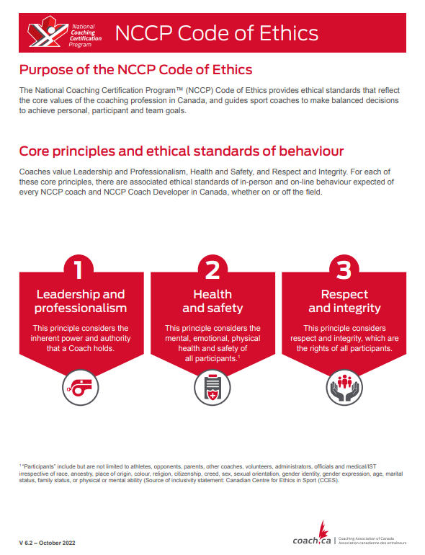
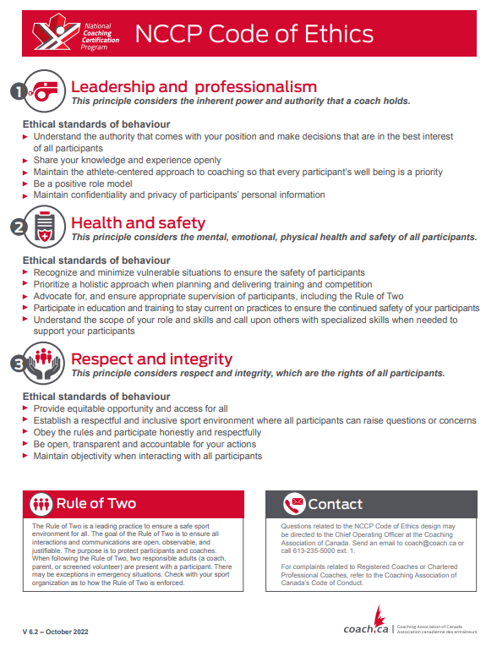

NCCP <Insert Sport> Coach Developer Code of Conduct
Disclaimer: This Sample NCCP Coach Developer Code of Conduct was developed by the Coaching Association of Canada (CAC) for guidance purposes only. It may be customized by governing organizations as required and at their discretion. By using this Sample NCCP Coach Developer Code of Conduct, governing organizations agree that the CAC shall not be held responsible for any of its content or use by any governing organization.

In my role as a Coach Developer in the National Coaching Certification Program (NCCP) for the Click or tap here to enter text. (governing organization), I, Click or tap here to enter text.(my name and NCCP#), expressly agree to be bound by and conduct myself in a manner consistent with this Code of Conduct, as well as any other relevant and applicable policies, including, without limitation, the Universal Code of Conduct to Prevent and Address Maltreatment in Sport (UCCMS).
I understand that if I fail to follow this Code of Conduct, I may be subject to disciplinary sanctions (consequences or penalties), including, without limitation, losing my Coach Developer certification status.
Code of Conduct
I shall:
- Participate in all required training and evaluation components of the Coach Developer pathway.
- Support the common goals and objectives of Click or tap here to enter text. (governing organization) as it serves the membership at large.
- Avoid discrediting specific sponsors, suppliers, employers, or other partners.
- Support key personnel and systems of the NCCP and partner organizations.
- Demonstrate ethical behaviour and always respect the NCCP Code of Ethics.
- Attend all professional development required for my growth as a Coach Developer and continuously seek to improve my personal abilities and performance.
- Exhibit exemplary professional behaviour at workshops or evaluation sites.
- Approach technical and non-technical problems and issues in a professional and respectful manner, seeking solutions that support due process.
- Place the best interest of those taking part in the workshops and evaluation events ahead of my personal interests.
Refrain from all forms of Prohibited Behaviour or Maltreatment, as those terms are defined in the UCCMS, as amended from time to time, including, without limitation, any form of physical, psychological or sexual maltreatment, as defined in the UCCMS.
Responsibility
If there’s disagreement or misalignment on issues, it’s the responsibility of the Coach Developer to seek alignment with the objectives, goals and directives of Click or tap here to enter text.(governing organization).
In the event of any breach of the UCCMS, this Code of Conduct or any other applicable conduct rules or policies that apply to me, I may be subject to disciplinary action pursuant to Click or tap here to enter text. (governing organization)’s relevant and applicable policies and procedures.
I hereby declare that I’ve read the above and understand and accept the terms and conditions outlined.

Click or tap here to enter text.
Name

Signature

Click or tap to enter a date.
Date

When adapting the NCCP Operations Manual…
- Remove the CAC disclaimer.
- Include any sport-specific details.
- Delete this box when you have finished adapting the NCCP Operations Manual.

Template for Coach Developer Self-Nomination Letter

Date Click or tap to enter a date.
City and Province/Territory or residence Click or tap here to enter text.
Name Click or tap here to enter text.
NCCP# Click or tap here to enter text.

Dear Click or tap here to enter text., (Provincial/Territorial Sport Organization, Provincial/Territorial Coaching Representative),
Please be advised of my interest in becoming a Coach Developer, in the following role
- Learning Facilitator
- Coach Evaluator
- Master Coach Developer
for the following contexts and/or workshops
- Click or tap here to enter text.
With this letter, I have enclosed an application form that demonstrates my experience in and commitments to sport and particularly to Click or tap here to enter text. (sport name). I am ready to begin the Coach Developer training and evaluation process in the hope of receiving my Coach Developer certification.
I would be pleased if you would forward my name as a Coach Developer candidate. Please contact me if you require further information or have any questions about my application.

Click or tap to enter a date.
Signature Date

Click or tap here to enter text. Click or tap here to enter text.
Email address Primary phone number

Encl.: Résumé
Letter(s) of Support

Template for Coach Developer Application Form
Date Click or tap to enter a date.
City and Province/Territory or residence Click or tap here to enter text.
Name Click or tap here to enter text.
NCCP# Click or tap here to enter text.
Languages Click or tap here to enter text.

Application Checklist:
☐ Cover letter
☐ Completed Coach Developer Application Form
☐ Completed Letter/Preliminary Coach Developer Worksheet
☐ Completed NCCP Make Ethical Decisions
☐ Résumé of your coaching experience, education and achievements
☐ Names and phone numbers for 2 references

Declaration
I hereby certify that the information I have provided with this application is true and complete.

Click or tap to enter a date.
Signature Date

Click or tap here to enter text. Click or tap here to enter text.
Email address Primary phone number

Template for Coach Developer Letter/Preliminary Worksheet
Date Click or tap to enter a date.
City and Province/Territory or residence Click or tap here to enter text.
Name Click or tap here to enter text.
NCCP# Click or tap here to enter text.

Dear Coach Developer Candidate,
We are delighted that you expressed an interest in becoming a Coach Developer. The purpose of the Coach Developer Preliminary Worksheet included in this letter is twofold:
- To learn more about you
- To give you an opportunity to learn more about the NCCP
Please submit the answers to the questions below with the rest of the documents when you submit your application package.
- Describe what you perceive to be the role of a Coach Developer.

- Describe the skills, abilities, and characteristics of an effective Coach Developer.

- What experience do you have working in adult education?

- What strengths do you bring to the position of Coach Developer?

- What skills and abilities do you think you need to develop to become an effective Coach Developer?

- In your own words, describe the structure of the NCCP.

- What are the five core competencies outlined in the NCCP?

- In your own words, what is the role of the Coach Developer in developing these competencies?

- Define:
- Outcome:
- Criteria:
- Evidence:

- In your own words, outline the purpose of Coach Developer training.

Template for Feedback Form
It is important to get feedback from participants to help us to improve our NCCP programs and quality of our coaches. The course you have just completed has been designed to provide you with skills and knowledge to become a more effective coach. Your feedback on the content presented and the ability of the course host to deliver this course will assist us in ensuring that the level of coach education is maintained at the highest level. Please take a moment to complete this short evaluation. All commentary will be held confidential.
Coach Developer name: Click or tap here to enter text.
Date: Click or tap to enter a date.
Workshop: Click or tap here to enter text. Location:

  - 1 Did not meet expectations
  - 2 Below Expectations
  - 3 Met Expectations
  - 4 Above Expectations
  - 5 Exceeded Expectations

Technical
The registration process was simple and easy to complete
The technology used was easy to navigate and effective
The price of the course reflected the quality of service provided

Additional Comments

Course Content and Materials
The course materials were easy to follow
The course content reflected the course description and goals
The course content provided the information necessary to be a better coach
Additional Comments

Coach Developer
The facilitator was available for questions
The facilitator was knowledgeable on the course material
The facilitator enabled me to reflect on ways that I might improve as a coach
Additional Comments

Overall Impression
I enjoyed taking the course
This course provided me with valuable tools and resources that I can use in my coaching endeavours
I would recommend this course to other coaches

Please list 3 positive aspects related to any area of the course

Is there anything you would recommend changing, adding or omitting from this course?

Additional Comments

When adapting the NCCP Operations Manual…
- Insert each of the tools you provide for your Coaches or Coach Developers.
- As many of these forms are now online or electronic tools, provide information about where these can be found. If you are simply including links or directions, and not the forms themselves, this can be included in the Business Operations section rather than as a tool.
- Some sample templates are provided for your reference. You do not have to use these templates. It is recommended you develop your own, and whenever possible make them electronic online forms.
- Note that the Tool Headings provided are required for Context Approval, so it is recommended you leave them in.
- Delete this box when you have finished adapting the NCCP Operations Manual.



